Aspire Leadership Program (Cohort 1: January-April 2024)

Module 1: Personal and Professional Development
Week-1: Connection

Reflection Prompt #1: Please answer the following questions in your Google Document.

A) Where do you reside currently?
Ans: Currently I live in Dhaka, Bangladesh.

B) What year of your undergraduate program are you now pursuing, or what year did you complete your undergraduate program?
Ans: Currently I am in my 2nd year.

C) What is your area of study?
Ans: Electrical and Electronics Engineering.

D) What would you like to learn or gain from the Aspire Leaders Program?
Ans: Through this program, I would like to achieve the qualities and ways of how to become a good and efficient leader with prolific experiences in future.

Reflection Prompt #2: Keeping in mind that no single test is definitive, what are the most notable ways in which the BigFive test results align with, or are different from, your own understanding of yourself, especially with regard to your strongest two scales. Which two subscales are notable to you and why?

Ans: From my perspective, I have come to align my strengths especially in Extraversion and Openness to different experiences, although they shouldn't have been according to my personality. After finishing my high-school, I have got the opportunity to work with two companies, one foreign and another national. Working with them, I have come to know about the qualities and strengths which I have never faced before. Being extrovert and open to creative things – these two qualities came to me from facing different situations. That’s why I prefer these two subscales to be notable.

Reflection Prompt #3: Given the BigFive test results and your reflections in Reflection #2, how might you use your understanding of your personality if (pick one of the following options A-D to answer):

B) You are interested in building a start-up:
- How would you prepare a project plan? Who would you speak with and why? What would you ask the person and why?

Ans: In order to build a start-up, a brief overview about the project or product is to be studied, including its social, economical, political and administrative aspects. From my point of view, it is essential to consult with business professionals of that particular line of my interested area, or talk with those people who are already involved with similar kinds of start-ups. Discussions will be based on how beneficial the startup can be, what sort of strategies need to be done to make the foundation strong, sources of investment and funds, product quality, target customers etc.

Week-2: Reflection

Reflection Prompt #4: Write responses to the following three prompts in your Google Document.

A) Given your understanding of yourself, and your reflections from the BigFive personality test, what personal and professional skills will be most important for you to develop?

Ans: From my perspective, after having the BigFive personality test, I would like to expertise myself in communication and cooperating skills along with personal grooming.

B) Why are these the most important?

Ans: These are essential for workplace cultures and can place a good contribution in one’s career ahead.

C) What are the top two or three actions you will take to build your personal and professional goals?
Ans: Communicate with people having diversified cultures, setting a daily to-do-list of my tasks and activities and connect with those on LinkedIn who will be having similar types of career prospects.

Week-3: Reflection

Reflection Prompt #5:

Drawing on the introduction to yourself drafted in Reflection #1, your other Reflections, your BigFive results, and the career videos, practice and revise a 3 minute (~500 word) introduction to yourself.

- Name
- Education
- Residence
- Work Experience
- Strengths and Weakness
- Hobbies and Interests
- Summary of your BigFive test results. (Explain your best sides).

Ans: Hello everyone. This is Daiyan Ibnul Aswad from Bangladesh. I am currently a 2nd year undergraduate student in BRAC University, studying in Electrical and Electronics Engineering. Previously, I had the opportunity to work with two educational organizations, one is Epsilon International and the other is Rico International. In Epsilon, I was appointed as a Lecturer and Content Creator for those students who are studying under Edexcel and Cambridge curriculums. In addition, I also got the chance to be a coordinator of their IELTS batches, where my task was to create question materials, books, lecture sheets etc. Moreover, I was a Student Counselor in Rico International, whose motive was to send students abroad for their continuation of higher studies. About my personal grooming, I worked as a tutor and a volunteer of a children-based organization called Phulkuri in Bangladesh during my school days. Currently I am working in the Electrical and Robotics Club of my university as a general member.

My strengths are that I am hugely patient and analytical in my work, and love to think creative ideas and solutions. Besides, I am a good listener and note-taker. On the other hand, my weakness is that sometimes I get hesitated and frustrated with different circumstances and for this reason my work gets hampered, therefore breaking my obedience with time and dedication.
From my childhood, I have loved sports, traveling, watching movies, reading scientific and commercial magazines etc.
To sum up, after giving the BigFive test, I found myself strong enough in the ‘extraversion’ and ‘openness to others’ sections. I sincerely agree that the better you are, the more open you can be to others. Throughout this whole program of Aspire Institute, I would like to gain my knowledge on leadership skills and implement them in my future career for betterment. Although I had the intuition to become an engineer, after doing this program, I hope that I can enrich my engineering and leadership skills in upgrading the technological world furthermore.

Global learning experience
Societal Impact and Focused grooming

Reflection Prompt #6:

What did I learn about presenting from listening to peers' presentations? Describe your experience of introducing yourself and your resume: What went well? What could've gone (even) better? What would you do to prepare for future professional presentations?

Ans:

- jerenannagurbanova0406@gmail.com

sundaymiriam@gmail.com

Ghassaq02@gmail.com

rafaelsmn@al.insper.edu.br

shahidkhansocialworker@gmail.com

Mahletgirma911@gmail.com

Module 2: Immersive Learning

Masterclass 1: Founder Mindset, the Magic of Commitment

Pre-Masterclass questions:

- What are some key qualities or characteristics you believe contribute to success as a business founder or leader?
Ans: Successful founders and leaders have a clear vision, adapt to changing circumstances, are resilient, passionate, effective leaders, creative, empathetic, focused, and decisive. They also operate with integrity, earning trust and credibility.

- What does the term "founder mindset" mean to you? What characteristics do you think contribute to this mindset?
Ans: The "founder mindset" refers to a set of attitudes, beliefs, and characteristics commonly found in successful business founders, including: entrepreneurial spirit, visionary thinking, resilience, creativity and innovation, passion and drive, adaptability, resourcefulness, growth mindset, customer-centric focus, and leadership and team building.
- Have you encountered any examples of individuals who embody this type of mindset in your personal or professional life? What stands out to you about them?

Ans: Elon Musk, Bill Gates and Steve Jobs are examples of individuals who embody the founder mindset, characterized by visionary thinking, relentless drive, creativity, and determination. They have turned their ideas into successful businesses through their unwavering commitment and ability to overcome obstacles.

Module 3: Aspire Horizons Course

Week 1: Understanding yourself as a leader

Why should we care about leadership?

- Act like an owner in your world
- Personal growth
- Team Performance
- Direction and Vision
- Change management
- Inventing the future
- Secure your personal future
- Community builders
- Global collaborators
- Economic catalysts
- Agents of change
- Education and Skills amplifiers

Leadership types: Personal, relational, inspirational, responsible, supportive, contextual.

Reflection Prompt-1:

## Note the key takeaways on leadership qualities you noticed in the video. Identify the qualities you would like to work on and those that you have. What steps might you take to build or bolster your leadership skillset?

I am currently studying in EEE in BRAC University. My interest lies in the 4th IR technology stacks along with its utilisations on business, environment and health. I would like to continue my higher studies with areas like IoT, ML, Robotics etc.

Week 2: Understanding context and building trust

Reflection Prompt-2:

Video 1: Introduction to Institutional Voids
https://youtu.be/-c203j_uBlI

Video 2: Institutions that Facilitate Change
https://youtu.be/TPa6OnVNsZ4

Video 3: Narayana Health Heart Hospital Example (Dr Devi Shetty)
https://youtu.be/YCcPbCuA5yw
Compensating for institutional voids: Scalable Heart Surgery (Incubator of Startups).
Driving modules: Insurance, Telemedicine, Medical education, transportation, social services.

Video 4: Babban Gona Example
https://youtu.be/fW5oG9MAh9w?si=2qdxE6saMKPJDf5R

Video 5: Contextual Intelligence
https://youtu.be/uwlV3Ouna2k?si=kygbflKbGHDc5TPN

Video 6: Introduction Trust + Alibaba Example
https://youtu.be/d-V4rLwHAZw

Core side of the business of Alibaba is INSPIRING TRUST
Website visualisation, trustpass, wangwang, alipay.

Video 7: Banco Compartamos Example
https://youtu.be/ZSJRf_Ym4zc

Video 8: Zipline Example
https://youtu.be/lkylsIxwAgg

Transaction facilitator, Credibility enhancer, aggregator, adjunctification, Information analyzer.

Think of an organization, large or small, where you live that relies on trust. How is trust important to their work? How do they build and maintain trust?

Ans: At every workplace, whether it's a small or large organization, it is essential to create communication channels with each and every employee of any profession. As one gradually starts to get acquainted with every member, he or she can then build trust upon that particular person. Doing office chores, grabbing for conversations, making sudden awful attention-seeking announcements - all these things are maintained when trust is built between employees. Through trust, individuals feel comfortable sharing their situations with the organization, knowing that their confidentiality will be respected. It is also crucial in ensuring that those in need believe in the organization's ability to provide support consistently and dependably. Additionally, building personal connections, maintaining consistency and transparency are also essential necessities in order to build and maintain trust.

Week 3: Digital Transformations and AI: What Every Leader Needs to Know

Digital Transformation and AI Part-1:

**Google acquainted the company NEST.
**IoT interface of NEST app.
**Voice interface, sensor-based instructions
**Five properties of Digital Signals: Quantized, Error free, infinitely reproducible, standard protocol dependent, zero marginal cost.
**Manipulation and response to digital transformation (Home thermostats)

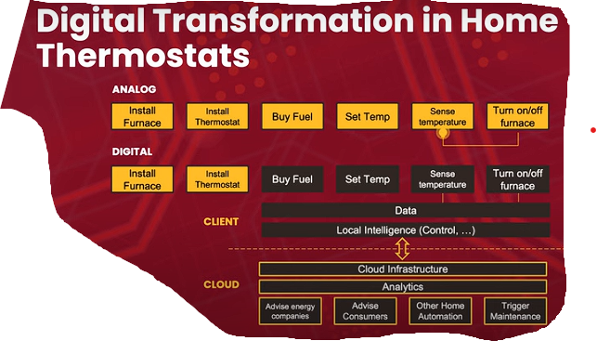

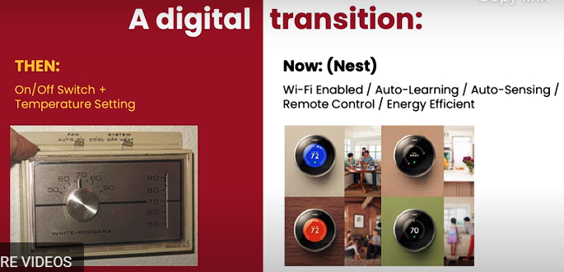

Creative thoughts:
What is an example of the effect of Digital Transformation that you've experienced recently in your life or in your community?

Digital Transformation and AI Part-2:

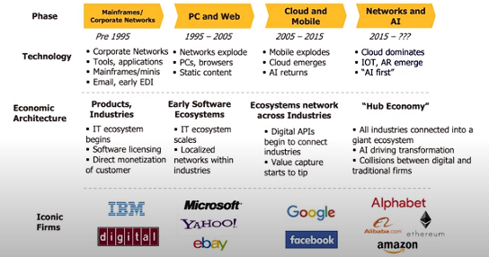

Creative thoughts:
When describing the democratization of the media industry due to platforms like Twitter, it was mentioned how this change can be both positive and negative. We learned about some of the positive effects of this. What are some negative effects or challenges you can think of?

The Age of AI
Strong AI: Think and act in a way that matches human intelligence.
Weak AI: Activities that computers perform while these are done by humans before. (large data sets and computing power).

Creative thoughts:
The lecture went over the idea that there will always be resistance towards new technology. What are your thoughts on this? How does it affect your own community?

“AI First” firms
Exponential organisations:
**Business Model– Value creation and value capture
**Operating model– Scale, scope, Learning

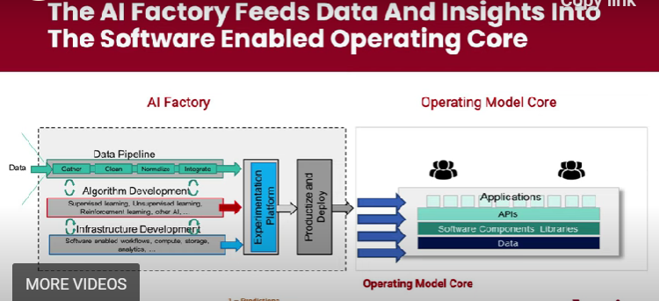
3 processes of AI: Prediction, Pattern recognition and process automation.

BUSINESS IDEA: ‘JUST WALK OUT TECHNOLOGY’ (in shops and malls): No lines and no checkouts.

Q) Use your own words to describe the findings of the study examining Human + AI collaboration over the capability frontier of AI performance.

Q) Briefly summarize why AI-first companies are facing backlash. How do you plan to use AI available to you as a tool rather than see it as a threat?

Reflection Prompt-3:

Keeping all you learned in these three lectures in mind, what are some issues in your community that you feel strongly about? List at least three and why they seem important. Respond to 1 other participant who mentions an issue similar to yours to build connection and share appreciation.

- No hospitals or clinics available immediately for better treatment facilities.
- No greenhouse yards or farms to cultivate crops, corns etc.

Week 4: Voices of leaders

Watch the Voices of Leaders Video

Discussion Post #3: What ideas from the video resonated with you? Why did these stand out? Respond to 1-2 other participant's posts.

Ans: Ideas from the video that resonated with me include; having a long-term growth mindset, building relationships on trust, and continuous learning because there is nothing like too much knowledge. These ideas stood out because they are important in the development journey of every leader. The video offered some interesting perspectives, but a couple of concepts really stood out to me:
The focus on teamwork as a key factor for fostering innovation was particularly noticeable to me. In the world of today that is interconnected, not a sole person or entity possesses all the solutions. By working together with others and combining different viewpoints and skills, we can address difficult problems more efficiently and generate solutions.
Fully agreeing, I believe that failure is a necessary aspect of innovation and should be welcomed as a chance to learn. Failing does not indicate weakness; instead, it serves as a pathway to development and enhancement. By changing how we view failure, we can create a culture of perseverance and ongoing growth in our pursuits.
The phrase trust is as ancient as a hill. I really connect with that saying. Being a young and up-and-coming entrepreneur taught me that trust is crucial for staying current and prosperous in the expanding industry of today. Establishing trust with your employees is the first step towards realizing your goals and visions as an entrepreneur.
Embracing the potential of artificial intelligence and advancing technology in this expanding population.

Watch the Video on Preparing a Project Proposal

Project proposal elements:
- Problem Statement (approximately 300 words):
- What is the problem?
- Who is affected?
- Why should we care?
- Who else is addressing the platform?

- Project Plan (approximately 400 words):
WHAT ARE YOU GOING TO DO?
- What is unique about your plan?
- Who is on your team?
- How much will it cost?
- What is your timeline?

- Outcomes (approximately 300 words):
- Describe tangible results desired for the problem identified.
- Your outcomes should be measureable
- What will be your quantifiable output? This could be activities such as workshops, campaigns, prototypes etc.
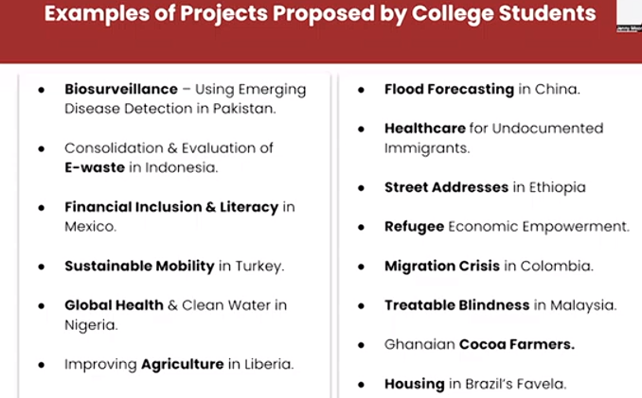

Discussion Post-4:

Consider a problem that you see in your community. This could be one of the issues you identified during Discussion Post #2, but it does not have to be. Which category does this problem fall into of these options: environment, public health, business, technology, justice and equity, arts and culture, or interdisciplinary? Define the Problem Statement in the appropriate subgroup channel in Discord:

- What is the problem?
- Who or what is affected?
- Why should we care?
- Why do you think no one has solved this yet?

**Project Proposal: Effect of Urbanization on Agriculture: A Loss Project in Today's World**

**1. What is the problem?**
Urbanization is rapidly encroaching upon agricultural lands, leading to the loss of arable land, environmental degradation, and disruption of traditional farming practices. This phenomenon poses a significant threat to food security, biodiversity, and the livelihoods of millions of people dependent on agriculture. As urban areas grow, they intrude on productive agricultural land, diminishing the amount of land available for farming. This leads to a decrease in food production, reduction in biodiversity, and greater strain on remaining farmland to satisfy expanding urban needs. Furthermore, as cities expand, pollution increases and can negatively impact soil quality and crop health.

**2. Who is affected?**
The effects of urbanization on agriculture affect a broad spectrum of stakeholders including farmers, rural communities, consumers, environmentalists, policymakers, and future generations reliant on sustainable food systems. Especially considering, farmers are the ones who experience the majority of the negative impacts of decreased land availability and struggle to maintain their livelihoods. Consumers could face increased food costs as a result of reduced supply. Ecologically, the loss of farmland leads to habitat destruction and puts the survival of indigenous species at risk. In the end, urbanization's negative impacts on agriculture affect the entire ecosystem, including human populations.

**3. Why should we care?**
Agriculture plays a critical role in ensuring food security and maintaining economic stability. We should care because the loss of agricultural land diminishes our capacity to produce food, exacerbates food insecurity, contributes to climate change through increased carbon emissions, and leads to the loss of biodiversity and ecosystem services critical for sustaining life on Earth. Moreover, climate change is worsened and sustainability is at risk due to environmental impacts like deforestation and soil degradation. Protecting farmland is essential to maintain a consistent food source, promote rural growth, and conserve the environment for future offspring.

**4. Who else is addressing the platform?**
Numerous organizations, governments, research institutions, and advocacy groups are addressing the challenges posed by urbanization on agriculture through various initiatives, policies, and research projects.

**5. What is unique about your plan?**
Our strategy centers on taking proactive steps to reduce the effect of urbanization on agriculture. Instead of just treating the symptoms, our goal is to introduce measures that will prevent additional loss of agricultural land and encourage sustainable urban growth. Collaboration among urban planners, policymakers, and agricultural experts can lead to the discovery of creative solutions that address the conflict between urban growth and agricultural conservation.

**6. Who is on your team?**
Our team needs a range of skills, such as urban planners, agricultural economists, environmental scientists, policymakers, and community stakeholders. It is crucial to work together with local governments, NGOs, and agricultural associations in order to carry out successful strategies and gain support from important stakeholders.

**7. How much will it cost?**
The cost of the project will vary depending on the scale and scope of activities, but we estimate a budget of around 5 crores to cover research, outreach, capacity building, and implementation efforts over a two-year period. Funding would be required for research, outreach campaigns, policy advocacy, arrangement of , and capacity-building initiatives. A detailed cost-benefit analysis would be conducted to ensure efficient allocation of resources and maximize the project's impact.

**8. What is your timeline?**
The project timeline is structured for about 2 years in order to account for the issue's complexity and the necessity of finding lasting solutions. The beginning stages will prioritize research and involve stakeholders to guide policy suggestions and action plans. Implementation of interventions would be carried out gradually, with continuous monitoring and evaluation to gauge effectiveness and adjust strategies as necessary. Following phases are structured to distribute the workload and planned strategies:

- Phase 1 (Months 1-6): Research and stakeholder consultation to assess the impact of urbanization on agriculture, identify best practices, and develop tailored interventions.
- Phase 2 (Months 7-12): Pilot implementation of strategies such as land-use planning, agroecological farming techniques, community-supported agriculture, and policy advocacy.
- Phase 3 (Months 13-24): Scaling up successful interventions, monitoring and evaluation, knowledge sharing, and advocacy for policy reform.

**9. Describe tangible results desired for the problem identified.**

The intended outcomes consist of conserving and repairing farmland, advancing land-use planning methods, strengthening food security, and building resilient rural communities. Furthermore, our goal is to encourage sustainable urban development that harmonizes economic advancement with environmental protection, forming cities that are suitable for current and future populations.

**10. Your outcomes should be measurable. What will be your quantifiable output?**
Quantifiable outputs may include the implementation of land-use policies that prioritize agricultural preservation, the establishment of green belts or buffer zones around urban areas to protect farmland, the adoption of sustainable farming practices, and increased public awareness through educational campaigns and workshops. These outputs would contribute to beneficial outcomes such as:
- Number of farmers adopting sustainable land management practices.
- Hectares of agricultural land preserved.
- Reduction in greenhouse gas emissions.
- Number of policymakers influenced by advocacy efforts.
- Attendance and participation in workshops, campaigns, and training programs.

By implementing these strategies and measuring our progress, we aim to mitigate the adverse effects of urbanization on agriculture and contribute to building resilient and sustainable food systems for current and future generations.

Week 5: Addressing Community Challenges

Reflection Prompt #3
Identify at least three different people who have experience with or are affected by your chosen problem. What questions would you need to ask them to better understand the problem and to think of potential solutions?
Here are three different people who could provide valuable perspectives:
- Smallholder Farmer:
  - What specific challenges do you face due to urbanization encroaching upon agricultural lands in your area?
  - How has the loss of arable land affected your livelihood and agricultural productivity?
  - What traditional farming practices have been disrupted or lost due to urban expansion, and how can they be preserved or adapted?
  - What support or resources do you need to cope with the impacts of urbanization on agriculture?
  - Are there any innovative solutions or initiatives you believe could help mitigate the negative effects of urbanization on agriculture in your community?
- Urban Planner or Government Official:
  - What strategies or policies are currently in place to manage the impact of urbanization on agricultural lands?
  - How do urban development plans take into account the preservation or mitigation of agricultural areas?
  - What are the main challenges faced in balancing urban expansion with agricultural preservation or sustainability?
  - Are there any successful case studies or best practices from other regions or countries that could be applied to address this issue?
  - How can collaboration between urban planning departments, agricultural authorities, and community stakeholders be improved to address the challenges posed by urbanization on agriculture?
- Environmental Scientist or Conservationist:
  - What are the environmental consequences of urbanization encroaching upon agricultural lands?
  - How does the loss of agricultural biodiversity impact local ecosystems and wildlife?
  - What sustainable land management practices can be implemented to mitigate the environmental degradation caused by urban expansion?
  - Are there any ecosystem-based solutions or nature-based approaches that could help restore degraded agricultural lands?
  - How can community engagement and education be leveraged to promote conservation efforts and raise awareness about the importance of preserving agricultural biodiversity amidst urbanization?
By engaging with these stakeholders and asking pertinent questions, we can gain a comprehensive understanding of the multifaceted challenges posed by urbanization on agriculture and identify potential solutions that address the needs and concerns of those directly affected by the issue.

Talk to People Affected By Your Problem
Talk to at least three different people about your problem. These might be the people you identified in Reflection Prompt #3, or they can be different people. Ask them the questions you generated in Reflection Prompt #3.
It has been a great opportunity for me to engage with three different individuals to gain insights into the problem of urbanization's impact on agriculture:

**1. Smallholder Farmer:**

I visited Mr. Patel, a smallholder farmer who owns a modest farm on the outskirts of a rapidly urbanizing town. Here are the key points from our conversation:

- Mr. Patel expressed deep concern about the encroaching urban development in his area, which has led to the loss of valuable agricultural land.
- He highlighted how the shrinking availability of arable land has forced him to reduce the variety of crops he can cultivate, affecting both his income and food security.
- Mr. Patel lamented the disappearance of traditional farming practices in the face of urbanization, as younger generations are less inclined to pursue agriculture as a livelihood.
- He emphasized the need for affordable access to modern farming technologies and support from the government to adapt to the changing agricultural landscape.

**2. Urban Planner:**

I interviewed Mr. Kamal, an urban planner working for the local municipal government. Here are the insights she shared:

- Mr. Kamal acknowledged the challenges posed by rapid urbanization on agricultural lands and recognized the importance of preserving agricultural areas for food security and environmental sustainability.
- He explained that while urban development plans do consider the preservation of green spaces, agricultural lands often face pressure for conversion into residential or commercial zones due to population growth and economic demands.
- Mr. Kamal highlighted the need for integrated land-use planning approaches that prioritize both urban development and agricultural preservation, along with community engagement in decision-making processes.
- He also stressed the importance of policy incentives and regulations to incentivize sustainable land management practices and discourage the indiscriminate conversion of agricultural lands.

**3. Environmental Scientist:**

I had a discussion with Dr. Jones, an environmental scientist specializing in land-use dynamics. Here are the key insights from our conversation:

- Dr. Jones emphasized the environmental consequences of urbanization on agricultural lands, including soil degradation, loss of biodiversity, and increased pollution from urban runoff.
- He explained that urban expansion often leads to habitat fragmentation, disrupting wildlife corridors and threatening native species that depend on agricultural landscapes.
- Dr. Jones highlighted the potential of ecosystem-based approaches, such as agroforestry and conservation agriculture, to restore and enhance the ecological resilience of agricultural lands amidst urbanization.
- He emphasized the importance of interdisciplinary collaboration between scientists, policymakers, and local communities to develop holistic solutions that address the complex interactions between urbanization, agriculture, and the environment.

Through these conversations, it becomes evident that urbanization's impact on agriculture is a multifaceted issue that requires collaborative efforts and integrated approaches to mitigate its adverse effects on farmers, communities, and the environment.

Reflection Prompt #4
Reflect on what you learned from your conversations. What new insights did you gain from your conversations? What ideas do you have for a way to begin addressing the problem? Identify at least two.

Discussion Post #5
Submit this Discussion Post to either the #environment, #public health, #business, #technology, #justice and equity, #arts and culture, or #interdisciplinary channel for your Group.

Discussion Post #5: Prepare a summary of your ideas and learnings.

- Who did you talk to?
- Why did you talk to them?
- What did you learn?
- What ideas do you have to begin addressing or improving the problem?
1) Who do you talk ?
I got engaged with a smallholder farmer, an urban planner and an environmental scientist.
2) Why did you talk to them ?
By communicating with them, I had the opportunity to get a vast idea and scenario of the agriculture industry and its diversified sectors around my country. In addition, regarding the farmers, manufacturing of foods and crops, business and stakeholders related to the agro-economy -- all these gave me a vivid picture of how the rigorous conditions of agricultural sector in our country is ongoing.
3) What did you learn?
From my perspective, I would like to narrate that in order to create a sustainable agro economy, it is vital to have a good collaboration between the farmers, farm owners and the political stakeholders, so that the overall ecosystem of the agriculture can be changed and made into a vast economy throughout the country.
4) What ideas do you have to begin addressing or improving a problem? Usage of 4th IR technologies such as installation of IoT devices, smart pumps and irrigation systems for checking real-time data, monitoring the overall performance and then doing statistics on each and every food and crop. In addition, farmers need to be vocationally educated with these new emerging technologies through which they can find it more easier to navigate their crops and farms.

Talk to Another Participant About Your Ideas to Improve the Problem
Join a Discord Meeting Room at a time convenient for you. We recommend arranging a time to join a Meeting Room with others who have contributed to whichever one of the topic channels you are contributing to (#environment, #public health, #business, #technology, #justice and equity, #arts and culture, or #interdisciplinary).
Share your answers to Discussion Post #5. What suggestions or insights do your peers have to share with you about your idea?

Week 6: Being in Action in Your Communities Worldwide

Step 1: Reflection Prompt #5

Building off of one of the ideas to address the problem you identified last week, start to draft part two of the project proposal, the Project Plan. Answer the following:
- What is unique about your idea?
- Who would you need on your team?
- How much would it cost?
- What would the timeline be?

–What is unique about your plan?**
Our plan focuses on holistic solutions that integrate sustainable land management practices, community engagement, policy advocacy, and technological innovations to mitigate the adverse effects of urbanization on agriculture.

–Who is on your team?**
Our interdisciplinary team comprises experts in agriculture, environmental science, urban planning, policy analysis, and community engagement, ensuring a comprehensive approach to addressing the issue.

–How much will it cost?**
The cost of the project will vary depending on the scale and scope of activities, but we estimate a budget of $500,000 to cover research, outreach, capacity building, and implementation efforts over a two-year period.

–What is your timeline?**
- Phase 1 (Months 1-6): Research and stakeholder consultation to assess the impact of urbanization on agriculture, identify best practices, and develop tailored interventions.
- Phase 2 (Months 7-12): Pilot implementation of strategies such as land-use planning, agroecological farming techniques, community-supported agriculture, and policy advocacy.
- Phase 3 (Months 13-24): Scaling up successful interventions, monitoring and evaluation, knowledge sharing, and advocacy for policy reform.

Step 2: Reflection Prompt #6
Define your Project Plan Outcomes. Answer the following:
- What are the desired results of your proposed project plan?
- What would be the quantifiable output? This could be activities such as workshops, campaigns, prototypes, etc.

–Describe tangible results desired for the problem identified.**
- Increase in the adoption of sustainable land management practices by X% among farmers in urbanizing areas.
- Preservation of X hectares of agricultural land through effective land-use planning and conservation efforts.
- Reduction in greenhouse gas emissions equivalent to X metric tons of CO2 through the implementation of sustainable agricultural practices.
- Increase in public awareness and support for policies promoting the integration of agriculture and urban planning.

–Your outcomes should be measurable. What will be your quantifiable output?**
- Number of farmers adopting sustainable land management practices.
- Hectares of agricultural land preserved.
- Reduction in greenhouse gas emissions.
- Number of policymakers influenced by advocacy efforts.
- Attendance and participation in workshops, campaigns, and training programs.

Step 3: Talk to Other Participants About Your Project Proposal

Join a Discord Meeting Room at a time convenient for you. Take turns sharing your proposals with your peers and providing feedback. You must speak with at least 3 other participants.

[[ALP Alumni: Extended leadership programs –
- Social Impact Seed Funding (SISF): Exploratory Grants
- Community Action Awards: Social Impact projects in Local Communities.

FINAL PROJECT PROPOSAL:

Effect of Urbanization on Agriculture: A Loss Project in Today's World

Urbanization is rapidly encroaching upon agricultural lands, leading to the loss of arable land, environmental degradation, and disruption of traditional farming practices. This phenomenon poses a significant threat to food security, biodiversity, and the livelihoods of millions of people dependent on agriculture. As urban areas grow, they intrude on productive agricultural land, diminishing the amount of land available for farming. This leads to a decrease in food production, reduction in biodiversity, and greater strain on remaining farmland to satisfy expanding urban needs. Furthermore, as cities expand, pollution increases and can negatively impact soil quality and crop health.
The effects of urbanization on agriculture affect a broad spectrum of stakeholders including farmers, rural communities, consumers, environmentalists, policymakers, and future generations reliant on sustainable food systems. Especially considering, farmers are the ones who experience the majority of the negative impacts of decreased land availability and struggle to maintain their livelihoods. Consumers could face increased food costs as a result of reduced supply. Moreover, preserving agricultural land maintains ecological balance, mitigates climate change, and supports sustainable development goals. Ecologically, the loss of farmland leads to habitat destruction and puts the survival of indigenous species at risk. In the end, urbanization's negative impacts on agriculture affect the entire ecosystem, including human populations.
Agriculture plays a critical role in ensuring food security and maintaining economic stability. We should care because the loss of agricultural land diminishes our capacity to produce food, exacerbates food insecurity, contributes to climate change through increased carbon emissions, and leads to the loss of biodiversity and ecosystem services critical for sustaining life on Earth. Moreover, climate change is worsened and sustainability is at risk due to environmental impacts like deforestation and soil degradation. Protecting farmland is essential to maintain a consistent food source, promote rural growth, and conserve the environment for future offspring.

Our strategy centers on taking proactive steps to reduce the effect of urbanization on agriculture. Instead of just treating the symptoms, our goal is to introduce measures that will prevent additional loss of agricultural land and encourage sustainable urban growth. Collaboration among urban planners, policymakers, and agricultural experts can lead to the discovery of creative solutions that address the conflict between urban growth and agricultural conservation.
Our team needs a range of skills, such as urban planners, agricultural economists, environmental scientists, policymakers, and community stakeholders. It is crucial to work together with local governments, NGOs, and agricultural associations in order to carry out successful strategies and gain support from important stakeholders.
The cost of the project will vary depending on the scale and scope of activities, but we estimate a budget of around 5 crores to cover research, outreach, capacity building, and implementation efforts over a two-year period. Funding would be required for research, outreach campaigns, policy advocacy, infrastructure development, and capacity-building initiatives. A detailed cost-benefit analysis would be conducted to ensure efficient allocation of resources and maximize the project's impact.

The project timeline is structured for about 2 years in order to account for the issue's complexity and the necessity of finding lasting solutions. The beginning stages will prioritize research and involve stakeholders to guide policy suggestions and action plans. Implementation of interventions would be carried out gradually, with continuous monitoring and evaluation to gauge effectiveness and adjust strategies as necessary. Following phases are structured to distribute the workload and planned strategies:

- Phase 1 (Months 1-6): Research and stakeholder consultation to assess the impact of urbanization on agriculture, identify best practices, and develop tailored interventions.
- Phase 2 (Months 7-12): Pilot implementation of strategies such as land-use planning, agroecological farming techniques, community-supported agriculture, and policy advocacy.
- Phase 3 (Months 13-24): Scaling up successful interventions, monitoring and evaluation, knowledge sharing, and advocacy for policy reform.

The intended outcomes consist of conserving and repairing farmland, advancing land-use planning methods, strengthening food security, and building resilient rural communities. Furthermore, our goal is to encourage sustainable urban development that harmonizes economic advancement with environmental protection, forming cities that are suitable for current and future populations. In addition, fostering community engagement and empowerment, promoting knowledge-sharing, and influencing policy change are integral outcomes.
Quantifiable outputs may include the implementation of land-use policies that prioritize agricultural preservation, the establishment of green belts or buffer zones around urban areas to protect farmland, the adoption of sustainable farming practices, and increased public awareness through educational campaigns and workshops, reduced carbon footprint of urban agriculture, number of policy recommendations adopted, and improvements in food access and affordability for urban residents.. These outputs would contribute to beneficial outcomes such as:
- Number of farmers adopting sustainable land management practices.
- Hectares of agricultural land preserved.
- Reduction in greenhouse gas emissions.
- Number of policymakers influenced by advocacy efforts.
- Attendance and participation in workshops, campaigns, and training programs.
By implementing these strategies and measuring our progress, we aim to mitigate the adverse effects of urbanization on agriculture and contribute to building resilient and sustainable food systems for current and future generations.

